Smart Pos
AP03
Specification

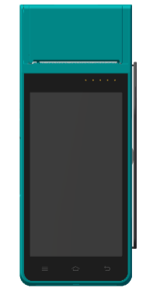

1.Introduction
AP03 Smart POS machine, android 5.1 operating system,5.0 inch screen touch, super long standby battery capacity is 3200 mah, thermal paper printing, 5 million pixels camera, China telecom 2 g / 3 g/wifi, bluetooth communication, magnetic stripe , induction IC card, contact IC card. Now,this fine workmanship and top quality machine is the best choice in the market.

2.Features
- Android 5.1 operating system: adopt the open android system, can let the user a simple and efficient development of the upper application,
- serviceable range : apply chain supermarkets, restaurants, convenience stores, clothing store, premises, bakery, cashier, pay, enters sells saves the business management function.

3.Technical Specification
Operating system | android 5.1
RAM | RAM:1GB , FLASH: 8GB
Extended stored | Micro SD card interface
Display screen | 5.0 inch screen touch
Touch screen | Capacitive touch screen, support the electronic signature
Printer | Built-in high speed thermal printer
Magnetic card reader | Support 1/2/3 tracks, two-way scratch card
IC card read-write | 1 Pcs
SAM gets stuck | 2 Pcs
SIM gets stuck | 1 Pcs
Non-contact card reader | Support ISO/IEC 14443 Type A&B, Mifare, felica card, in line with the EMV/PBOC PAYPASS specification
USB interface | A Micro USB OTG, compatible with USB2.0 HS standards, a Mini USB serial port
Communication | 3 g and 2 g network  Wi-fi communications, support hot spots  Bluetooth communication
GPS | Built-in GPS
Camera | 5 mega-pixel camera
Bar-code reader | Support 1 d / 2 d scanning
Multimedia | Support for recording, voice broadcast  Support video playback/recording
Password keyboard | Built-in password keyboard (virtual)  Support DES, 3 DES, RSA, SHA - 256 and AES algorithm
Battery | Lithium battery: 3600 mah, 3.7 V
power adapter | Input: 110 v to 240 v AC / 50 ~ 60 hz  Output: 5 v DC / 2 A  General Micro USB interface
Size | 191mm×80mm×46mm
Optional accessories | Write a stylus  Base, optional standard base (charging function only)

